Vermot-Desroches Matthias

Rapport de séance n°2

During this session, I started by finishing the CAD model of the support piece that I began last session. Here is the last update:

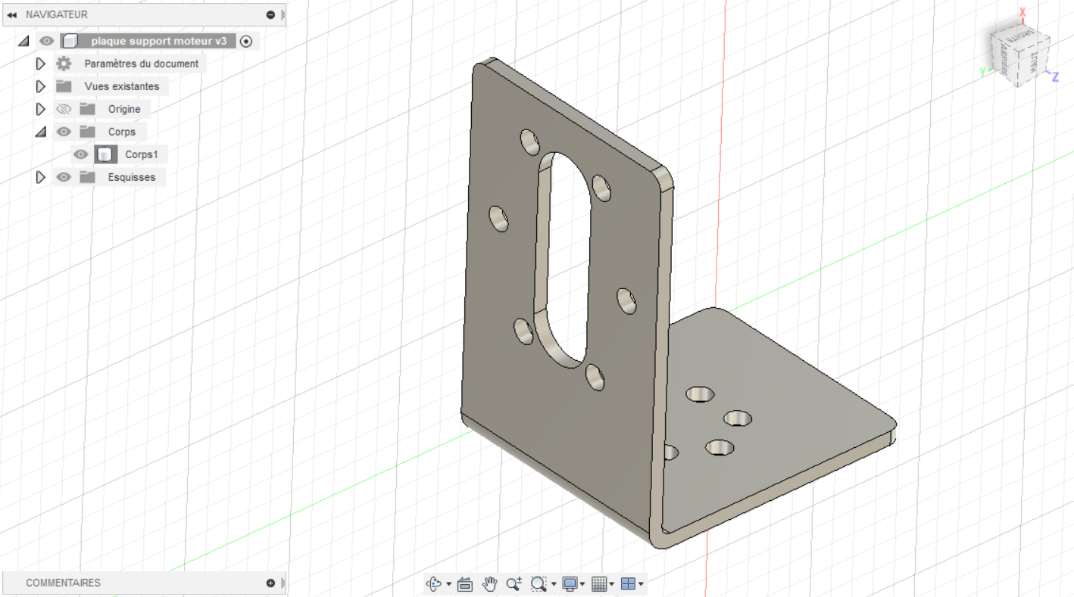

Then, I did another CAD model of this piece, but this time for the first realization that will be in wood.

Here is the last update of the CAD:

I only did half of the piece since it is for the wood model, I will simply make two half in order to see if it fit.

Then, I exported the sketch used to make the CAD model in order to make an svg file on Inkscape for the LASER cut.

Here is the svg file:

The lines are in red to make the machine understand that it needs to cut through them.

After that, I did an inventory of the things we had to buy for the project.

We needed: 4 servomotors, 5-6 motors + wheels ensemble, an accelerometer, an GPS, a magnetometer and 4 hubs.

I discussed with the professors about making the hubs in aluminum ourselves. After a long discussion, we decided that we will buy the hubs or maybe print them with resin, because machining aluminum with the mill would be too difficult.

Then, I did some research on the suspension and servomotor bond. I drew sketches of these research.

This was the first iteration:

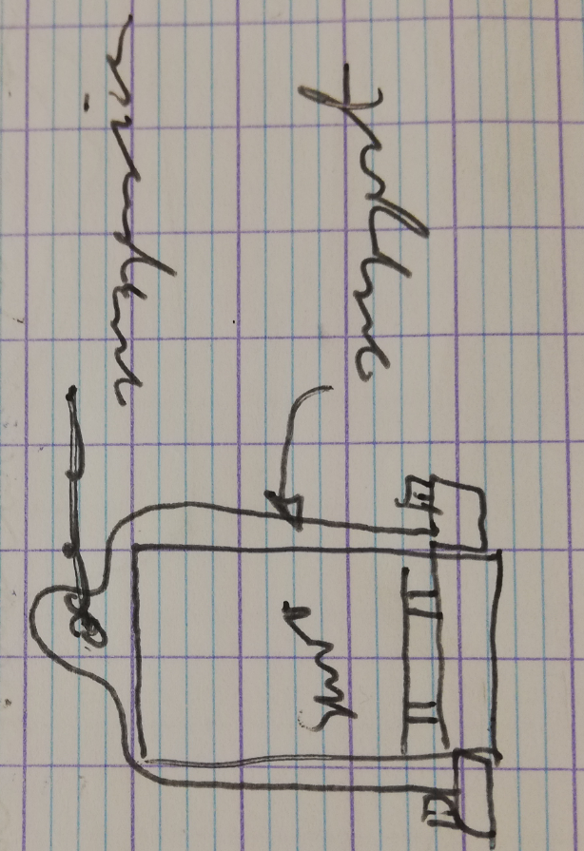

Here, we can see that the bond is made with a new support piece. To use this iteration, we would need to fix this new piece onto the same metal bar as the servomotor.

The second one was this:

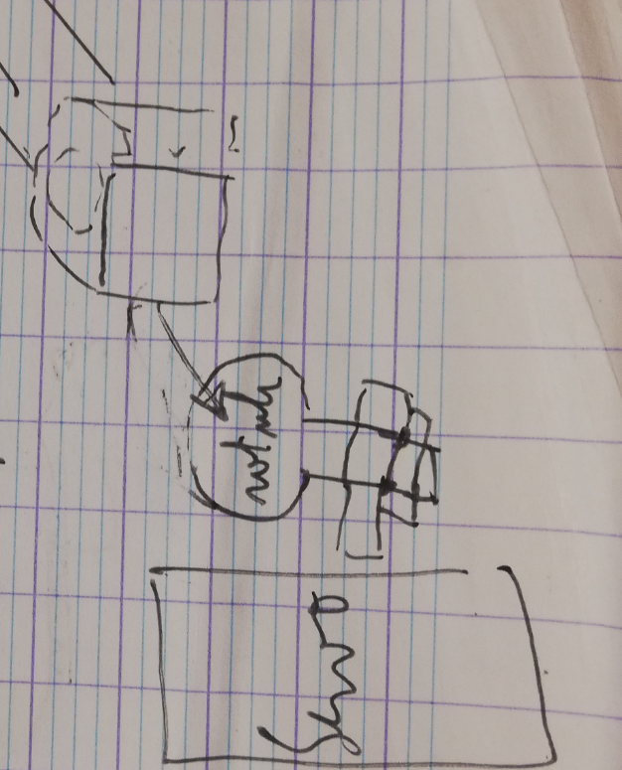

On this iteration, we would make a screw like piece with a ball joint on top. That way, the suspension will fit on the piece. The ball joint also allows the suspension to rotate in every direction. Lastly, the piece would be screwed on the servomotor.

The last iteration and the one we plan to use is this:

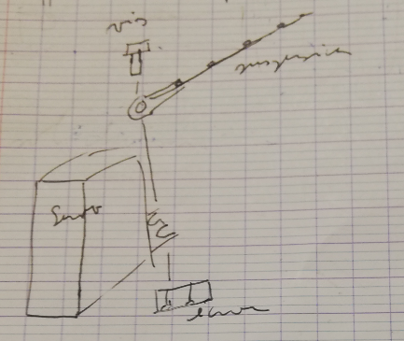

Here, we use a simple bolt ensemble to fix the suspension. That way, the suspension cannot rotate but we concluded that it was not necessary for our robot.